CASE STUDY · BRAND MANAGEMENT · INDONESIA

Coca-Cola’s Healthy Portfolio in Indonesia
Market report and analysis: companion to the strategy deck “Growing Coca-Cola’s Healthy Portfolio in Indonesia”
Curated by Toh Yu Heng, October 2026

Contents
Executive summary
1. Introduction: scope and definitions
2. Market overview
3. Regulatory and health environment
4. Consumer insights
5. Coca-Cola’s position in Indonesia
6. Portfolio review by brand
7. Competitors
8. Channels and media
9. Digital and social presence
10. Strategic implications
11. Outlook and watch-list, 2027–2031
Appendix A. Methodology, limitations and data conflicts
Appendix B. References
Tables
Table 1. Brands in scope: sugar, sweetener, indicative Nutri-Level grade and label fact
Table 2. Regulatory instruments: status at 18 Oct 2026 and what each means for the portfolio
Table 3. Official and medical voices on sweeteners, 2020 to 2026: none has endorsed them
Table 4. Forum scan: barriers voiced in 477 r/indonesia comments
Table 5. Portfolio at a glance: each brand’s job, main gap and funding
Table 6. Top Brand Index by category, 2024 to 2026
Table 7. How the local category leaders won
Table 8. Channels: scale, evidence and role in the plan
Table 9. TikTok, YouTube and dedicated accounts: competitors vs Coca-Cola Indonesia
Table 10. The four plays and the shared foundation: budget, scope and lead KPIs
Table 11. Illustrative return scenario, per year at scale and over 2027–31 (all inputs are team assumptions)
Table 12. Signals that would change the plan, and the response
Figures
Figure 1. Sparkling soft-drink servings per person, 2024
Figure 2. Drinks consumed often, Gen Z vs Millennials, April 2026
Figure 3. CCEP Indonesia revenue, FY2023 to H1 2026
Figure 4. Sugar per 100 ml and indicative Nutri-Level grade, by product
Figure 5. Instagram followers and engagement, 12 accounts, 18 Oct 2026
Figure 6. Budget by year and play, 2027 to 2031, US$M
Figure 7. Milestones and decision gates, November 2026 to 2031

Executive summary
Coca-Cola can grow its lower-sugar and functional drinks in Indonesia by closing three gaps (moment, shelf and trust) with US$10M over 2027–2031, released through three decision gates.
Key findings
- Indonesians drink 11 sparkling servings a person a year, against 172 in the Philippines [1]; soda is an occasional drink in a market built on water and tea.
- 54% try to eat low-sugar [2], yet 47.5% drink sugary drinks daily [3].
- Artificial sweeteners cap a drink at Nutri-Level C, Original’s grade, so the label will not make Zero’s case [4, 5].
- Bottler revenue fell 28% in 2023–25 [6, 7]; H1 2026 volume grew, led by Coke Zero Sugar [8].
- Rivals lead every lower-sugar and functional category: Aqua, Teh Pucuk Harum and Pocari Sweat [9].
- Three gaps hold the portfolio back: Zero is missing from soda moments; its sales are not proven outside modern trade, where it seems hard to find cold; and shoppers doubt sweeteners, while Powerade has no credible reason to buy yet.
- Our three portfolio Instagram accounts (Coca-Cola ID 97K, Frestea 61K, Minute Maid 16K) total 174K followers, fewer than Aqua’s one account (303K); all five brand accounts, including Sprite and Fanta, total 255K [10].
Who we target. Occasional soda drinkers aged 18 to 35 for Zero; runners, gym-goers and court players for Powerade; tea and juice drinkers for Frestea and Minute Maid Pulpy.
Where the US$10M goes. Play 1, Put Zero in soda moments, US$3.4M; Play 2, Put Zero within reach, US$2.2M; Play 3, Credible voices for Zero and Powerade, US$1.8M; Play 4, Facts first for tea and juice, a capped US$1.0M test outside the three gaps; shared foundation US$1.6M. By channel: creators 30%, delivery apps 24%, on-ground 21%, shelves 17% and TV 0%; tracking, geo tests and a reserve take the remaining 8%. A 2027 test budget of US$1.6M runs before the first gate releases the rest.
The next post. “Makan pakai Zero” goes live on Mon 7 Dec 2026 as the first post on a new official TikTok, with 6–8 food creators posting that week. Targets: 10,000 GrabFood code redemptions in four weeks in Jakarta (below 3,000 we re-cut the hook), 25%+ completion and 1%+ shares.

1. Introduction: scope and definitions
The report covers the five brands we treat as the brief’s “healthy beverage portfolio” and claims for each only what its label states.
Grades are indicative: A ≤0.5 g, B ≤6 g and C ≤12.5 g sugar per 100 ml; A allows no sweetener and B only natural ones [4, 5]. Sugar and sweetener figures in Table 1 come from the brand pages [11].
Definitions used throughout
- Growth means more buyers: brands grow mainly by adding light buyers [12].
- Coca-Cola in Indonesia is two companies: PT Coca-Cola Indonesia runs the brands and marketing [13]; CCEP bottles and distributes, and its PT Coca-Cola Bottling Indonesia holds Zero’s BPOM registration [14, 15].
- Money: Rp18,000 to US$1, rounded from Rp17,915 on 8 Oct 2026 [16]. Plan period 2027–2031; data to 18 Oct 2026.
Table 1. Brands in scope: sugar, sweetener, indicative Nutri-Level grade and label fact
Product | Sugar per 100 ml | Sweetener | Nutri-Level (indicative) | Label fact
Ades mineral water | 0 g (assumed) | None | A (assumed) | 0 g sugar
Coca-Cola Zero Sugar, Sprite Zero, Fanta Zero | 0 g | Artificial (Zero: acesulfame-K, sucralose) | C | 0 g sugar, stated with “contains artificial sweeteners”
Powerade Active Blue, Active White | 3.2 g | Sugar plus artificial | C | Contains electrolytes
Frestea range | 6.0 to 9.2 g | Sugar; Melati and Apel add stevia | B to C | Real tea; sugar shown openly (Melati 6.0 g)
Minute Maid Pulpy Orange | 9.0 g | Sugar | C | Contains vitamin C (25% AKG per 300 ml bottle)
Coca-Cola Original (reference) | 10.8 g | Sugar | C | None in this report
Sources: brand pages [11]; BPOM Regulation 10/2026 [4, 5]. Ades is not on the brand pages [11]; 0 g and grade A assume plain mineral water, to check on pack. Consumer-facing claims are limited to the label facts in Appendix A.

2. Market overview
Soda is an occasional drink in a market built on water and tea, so Zero has to grow inside the soda moments that already exist, and tea and juice need a focused, capped bet.
Indonesia is big but drinks little soda. It has 284.7M people, 49% of them Gen Z or Millennials [17, 18], yet the Philippines earns the Coca-Cola system 5.8 times more (€1,890m vs €328m, FY2025) [7]. Water is 66% of ready-to-drink volume and 34% of value; tea leads the rest [1].
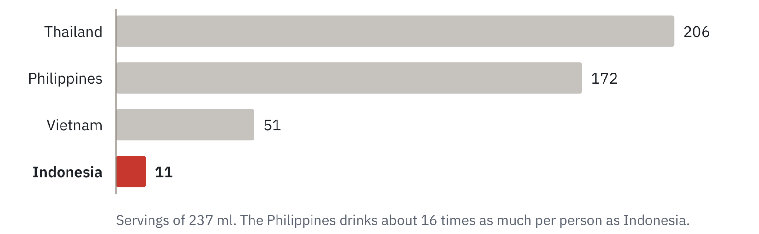
Figure 1. Sparkling soft-drink servings per person, 2024. Source: CCEP Capital Markets Event, May 2025 [1]; values from text extraction of CCEP’s deck
Growth is in water and less sugar. The soft-drink industry grew 1.8% in Q3 2025, all of it from bottled water [19]; reduced-sugar carbonates keep gaining [20]. 47% of Indonesians almost never drink soft drinks (c. 2019) [21], and Gen Z rank soda sixth of seven drinks they consume often (30%) [22].
Middle-class numbers fell 16% in five years. BPS counted 57.3M in 2019 and 47.9M in 2024 [23]. Household consumption growth slowed to 5.06% in Q2 2026 [24], and 77% put value first in health purchases [25]. CCEP: “affordability is more important than ever” [1].

3. Regulatory and health environment
Regulation grades artificial sweeteners no better than sugar, so “0 g gula” is a fact Zero can own while “healthy” is a claim the state and doctors contest.
20.4M adults have diabetes. That was the fifth-highest number in the world in 2024, and 73% of cases are undiagnosed [26]. Adult obesity reached 23.4% in 2023 [27], and 47.5% of Indonesians aged 3 and over drink sugary drinks daily (SKI 2023) [3].
Table 2. Regulatory instruments: status at 18 Oct 2026 and what each means for the portfolio
Instrument | Status at 18 Oct 2026 | What it means for the portfolio
Nutri-Level front-of-pack grades (BPOM Regulation 10/2026) | In force 17 Jun 2026 with a 24-month transition; drinks comply by 17 Jun 2028 [4, 5] | Zero and Original both grade C, so the label will not make Zero’s case; Ades grades A; Frestea Melati (stevia, 6.0 g) sits exactly on the B line; moving other flavours to 6 g or less is an R&D decision
Sugar-drink excise (cukai MBDK) | Targeted for H2 2027, Rp1.7tn budgeted; rates unset; proposed in 2020, budgeted since 2022, never collected [28, 29] | Helps zero-sugar lines only if levied on sugar content
Sugar, salt and fat limits (Government Regulation 28/2024) | Signed Jul 2024; products above future maxima may face advertising limits; maxima not set [30] | The risk sits with full-sugar lines
Constitutional Court ruling 110/PUU-XXIV/2026 | Late Sep 2026: partly grants a review of sugar, salt and fat information; YLKI wants warning labels [31] | Label pressure could come before 2028
Sources: BPOM and Cekindo [4, 5]; Republika and DDTCNews [28, 29]; Gebrak [30]; Katadata [31].
Table 3. Official and medical voices on sweeteners, 2020 to 2026: none has endorsed them
Date | Who | What they said
2020–2021 | Health portals | “Diet soda is safe” is a myth; low-calorie soda is not clearly healthier [32, 33]
Jul 2023 | Ministry of Health | Urged limits on artificial sweeteners; named aspartame and acesulfame-K (in Zero) as possible cancer risks at heavy intake [34]. BPOM’s reply nine days later covered aspartame only [35]
Apr 2026 | Ministry of Industry | Sweetened products still grade C, so makers have little reason to reformulate [36]
Jun 2026 | Health Minister (Instagram, as reported by iNews) | Graded stevia B and artificial sweeteners C or D [37]
Sources: KlikDokter [32, 33]; Antara [34]; BPOM [35]; Kontan [36]; iNews [37].

4. Consumer insights
Indonesians want less sugar in principle but keep a sweet palate and doubt sweeteners, so Zero should sell as a soda for soda moments, Powerade needs expert voices and Frestea should lead with real tea.
Most want less sugar; few have cut it. 54% try to follow a low-sugar diet [2], but 19% live sugar-free [38] and 62% like adding sugar to drinks [39].
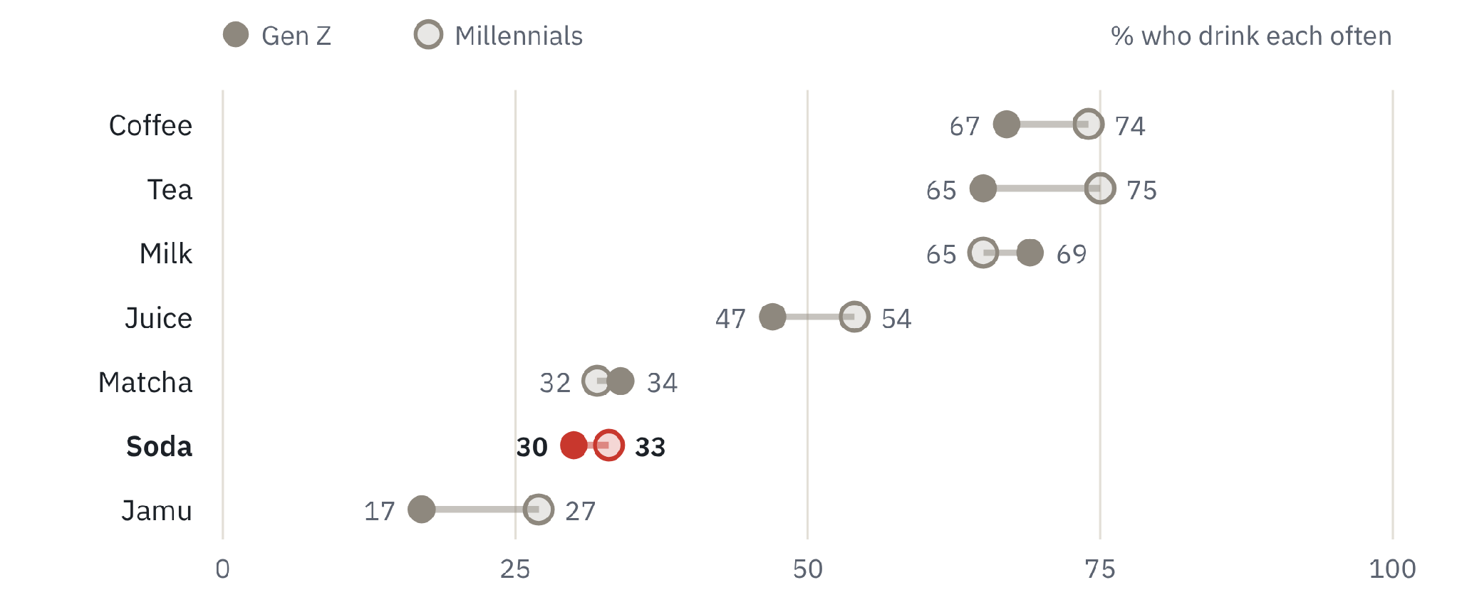
Figure 2. Drinks consumed often, Gen Z vs Millennials, April 2026. Source: Jakpat via GoodStats, n=1,238, Gen Z n≈520 [22]
What 477 forum comments say. We read r/indonesia threads from 2020 to 2026 [40]; the scan is qualitative and skews young, urban and online.
Table 4. Forum scan: barriers voiced in 477 r/indonesia comments
Theme | What we heard | Strength
Sweetener fear | 12 comments link sweeteners to diabetes, cancer or kidneys; to “can I get diabetes from Coke Zero?” a reply says “Yup. You can.” | Moderate to strong
Sweet palate and habit | 13 comments: “Since they cut the sugar, I can’t be bothered buying bottled tea” | Strong
Taste of sweeteners | 19 comments, 2 about Zero; 5 others praise Zero (Coke Zero Vanilla: “honestly this is seriously good”) | Moderate; weak for Zero
Health credibility | 7 comments: “Coke Zero still contains sweetener” | Moderate
Availability | 6 comments say Frestea is hard to find; unsold stock cannot be returned, so shops skip it | Moderate for Frestea
Price | 10 comments; none calls Zero expensive | Moderate
Boycott | 9 raise it and 5 dismiss it; 3 link Coca-Cola to local substitutes; a thread on a Bali plant closure blamed it in none of 24 comments | Weak
Source: team scan of r/indonesia comments, 2020–2026 [40].
The health-minded choose water: in one thread, mineral water drew 196 upvotes and “Sprite/Coke Zero” 16 [40].
“Healthy” means natural, and claims are doubted. 42% avoid preservatives or colourings, 36% choose low-sugar or low-calorie products, 12% put taste first and 38% doubt health claims (Populix, Dec 2025, n=1,100) [41]. Medical specialists are the top influence on wellness purchases (77%) [42]; 54% monitor their fluid intake [25], an opening for Powerade and Ades.
Few break the fast with a packaged drink. Only 7.9% name one their favourite; sop buah (fruit soup) leads at 33.1% [43]. Yet Coca-Cola’s sales more than double in Ramadan [44], and online FMCG spending rose over 60% in Ramadan 2026 [45].
Gen Z prefer Teh Pucuk Harum. 70.3% pick it as their favourite packaged tea, against 8.1% for Frestea (n=2,233) [46].

5. Coca-Cola’s position in Indonesia
Bottler revenue fell 28% in two years and was flat at constant currency in H1 2026; Zero in modern trade and at Ramadan is the base to build on, while general trade, tea and juice are the weak spots.
In reported euros, H1 2026 revenue was 11.8% below H1 2025; the whole fall was currency [8, 47].
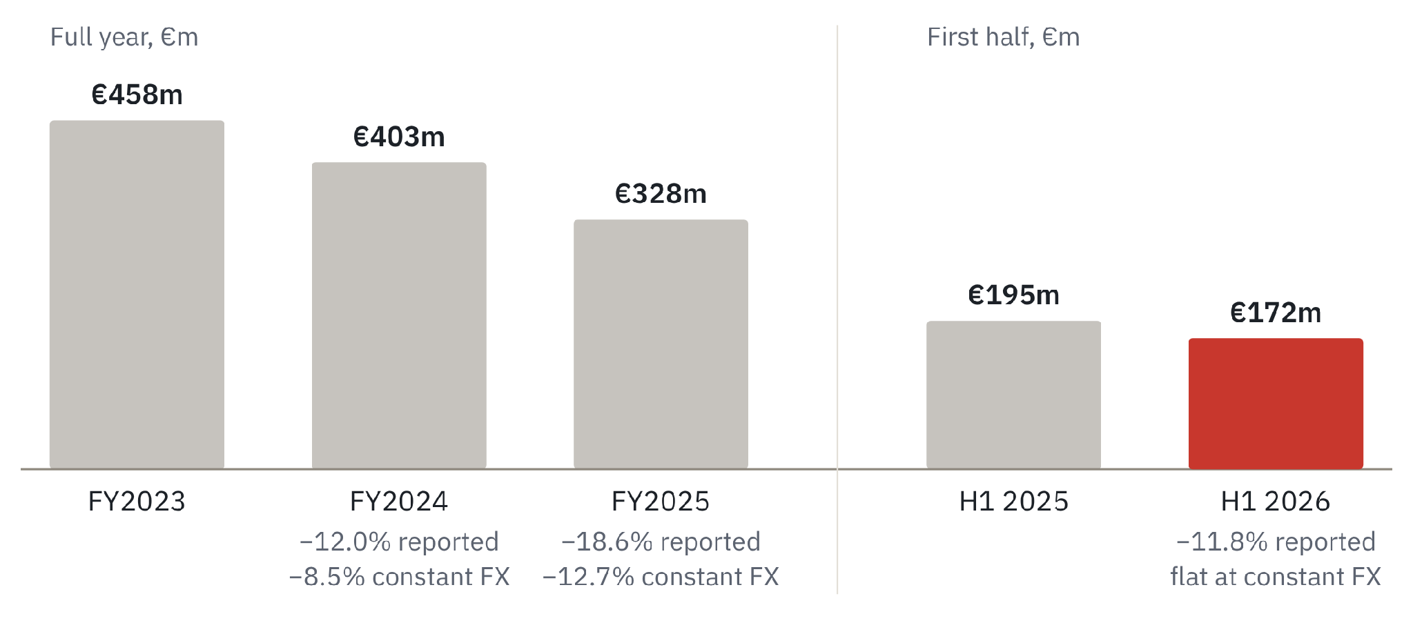
Figure 3. CCEP Indonesia revenue, FY2023 to H1 2026. Source: CCEP results [6, 7, 8, 47]; FY2023 restated
What the bottler says went wrong.
- Weak consumer: a “weaker consumer & macroeconomic backdrop” in FY2025 [7].
- Boycott: hit modern trade hardest in Q2 2024 [1], sat behind a €175m impairment in 2024 [6] and was last cited, as “a factor”, in H1 2025 [47].
- Reach: about 4M outlets are fed by 120,000 wholesalers [1]; distributors replaced CCEP’s direct delivery by end-2025 [7].
- SKU reset: about 60% of SKUs cut by end-2023 [48].
Volume grew in H1 2026. It rose by mid-single digits, led by Coke Zero Sugar, Fanta, Sprite and launches such as Coke Zero Vanilla and Sprite Nipis Mint; Powerade showed “encouraging early performance”; tea stayed in decline [8]. In Q1 2026 sparkling grew “particularly over the festive Ramadan period”, while juices and black tea fell and blackcurrant Frestea grew by double digits [49].
Zero’s share depends on the channel. Zeros rose from 3% to 7% of CCEP’s sparkling mix in 2025 (period and base not stated) [50] but are over 30% of its modern-trade soft-drink mix [1]. The bases differ, but we infer Zero is under-distributed outside modern trade: it seems hard to find cold there, to confirm with CCEP outlet data before Play 2 scales.

6. Portfolio review by brand
Each brand has a different job: Zero leads the plan; Powerade enters as challenger; Frestea and Minute Maid get a capped test on label facts; Ades supports.
Sugar per 100 ml runs from 0 g (Ades, Zero) to 9.2 g (Frestea Apel), against 10.8 g for Original [11].
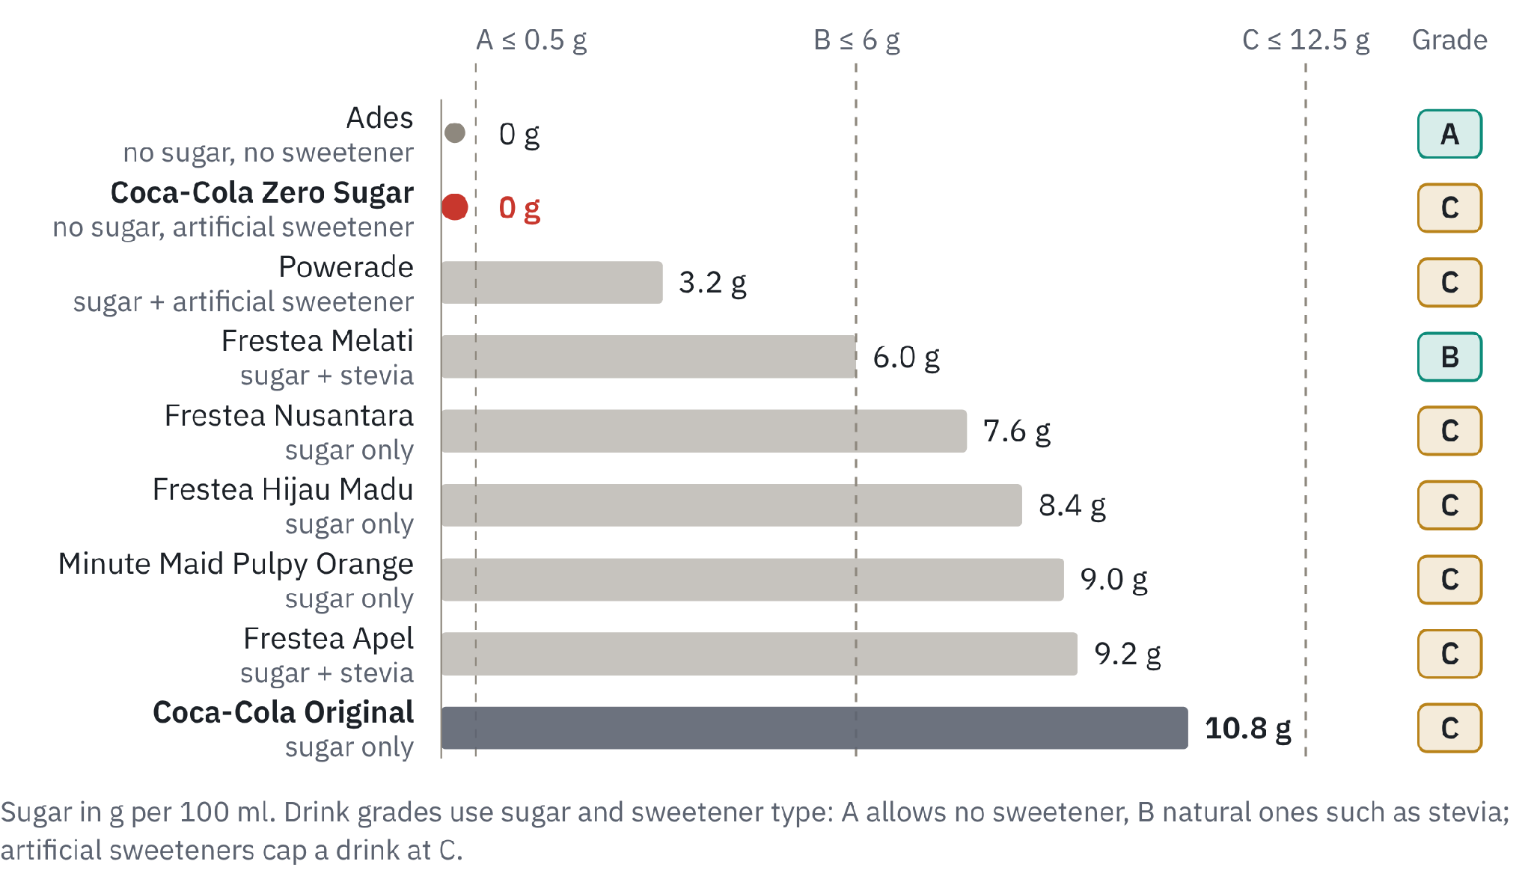
Figure 4. Sugar per 100 ml and indicative Nutri-Level grade, by product. Source: Coca-Cola Indonesia brand pages [11]; BPOM Regulation 10/2026 [4, 5]
Table 5. Portfolio at a glance: each brand’s job, main gap and funding
Brand | Job | Main gap | Funding in the plan
Coca-Cola Zero Sugar | Lead brand: occasional soda drinkers aged 18 to 35 | Moment and shelf; trust | US$5.8M: Plays 1 and 2 (5.6) plus 0.2 of Play 3 label-reading content
Powerade | Challenger: runners, gym-goers and court players | Trust | US$1.6M: the rest of Play 3
Frestea | Selective bet on tea drinkers: real tea, sugar grams shown openly | Outside the three gaps: facings and share of voice | Play 4: US$1.0M shared with Pulpy
Minute Maid Pulpy | Selective bet on juice drinkers, led by vitamin C | Outside the three gaps; no brand-index baseline | Play 4 (shared)
Ades | Support in the water pool; the only grade-A drink in the range | Price and distribution | No budget of its own; paired with Powerade at runs
Shared foundation | Official accounts, tracker, geo tests and reserve | All | US$1.6M
Source: team plan (Table 10); US$1 = Rp18,000 [16].

6.1 Coca-Cola Zero Sugar (with Sprite Zero and Fanta Zero)
- Evidence: relaunched Mar 2023 with a taste closer to Original, in 250 ml cans and 390 ml bottles, in modern trade and e-commerce only [51]. Tokopedia, 18 Oct 2026: Zero 390 ml Rp8,400, Original 390 ml Rp8,000 (marked down from Rp15,000), so no clear price gap [52].
- Gap: 2023–2024 campaigns were novelty plays (#ZeroWords, Riot Games, AI-made “Y3000”, K-pop) [51, 53, 54, 55]; Zero sat out the 69,000-moment Ramadan 2026 programme and Share a Coke 2025 [56, 57].

6.2 Powerade
- Evidence: launched 19 May 2026 (Active Blue, Active White, 400 ml) [11, 13, 58] with “ION4” electrolytes [13]; 3.2 g sugar per 100 ml plus sweeteners [11]; Rp6,000 at Indomaret [58]. Running is booming: 558+ events in 2025, up from 458 [59], and about 31,000 runners at the 2025 BTN Jakarta International Marathon [60].
- Gap: no credible reason to buy yet. Pocari Sweat scores 56.0 and Powerade is unlisted [9]; the category is held back by “brand scarcity and consumer misconceptions” [61]; we found no organic talk [40].

6.3 Ades
- Evidence: index 7.0 against Aqua’s 42.8 [9]; no official social account [10]; not on Coca-Cola Indonesia’s brand list [11]; 160,000 Frestea and Ades bottles at Istiqlal Mosque, Ramadan 2026 [56].
- Gap: water is a price and distribution war.

6.4 Frestea
- Evidence: index down from 12.0 (2024) to 10.0 (2026), behind Teh Pucuk Harum at 33.4, while Frestea Green Tea rose to 30.7 [9]. Relaunched 18 Sep 2025 with full-sleeve packs and a “rehat” (break) idea [62]; Blackcurrant became CCEP’s “#1 flavoured brand” [7]; the 2023 Ramadan game with Grivy built over 1M first-party profiles, 90% of identified buyers new to the brand [63].
- Gap: six forum comments say it is hard to find [40].

6.5 Minute Maid Pulpy
- Evidence: 27 g sugar and 25% of daily vitamin C per 300 ml bottle [11]; Rp6,457 for a 350 ml listing, though the brand page lists 300 ml and 1 L [64]; 16K Instagram followers [10].
- Gap: only 17% less sugar than Original per 100 ml, so it leads with vitamin C and states its grams.

7. Competitors
Rivals lead every lower-sugar and functional category. Local leaders won on value, distribution or credibility backed by heavy advertising; reformulation followed.
Rivals already sell less sugar. Teh Pucuk Harum Less Sugar carries BPOM’s “Pilihan Lebih Sehat” (healthier choice) logo and, by its maker’s claim, no preservatives or artificial sweeteners [65]. Forum users name Chi Forest, Tebs Zero and Kenangan Sparks as the zero-sugar drinks to beat [40].
Table 6. Top Brand Index by category, 2024 to 2026
Category | Leaders, 2026 index | Our brand, 2024 → 2025 → 2026 | Our position
Bottled water | Aqua 42.8; Le Minerale 21.5 | Ades 5.5 → 3.9 → 7.0 | Third
Packaged tea | Teh Pucuk Harum 33.4; Teh Botol Sosro 20.4 | Frestea 12.0 → 10.8 → 10.0 | Third, falling
Green tea | Nu Green Tea 33.0 | Frestea Green Tea 22.0 → 22.0 → 30.7 | Second, rising
Isotonic | Pocari Sweat 56.0; Mizone 23.6 | Powerade not listed (launched May 2026) | Entrant
Carbonated | Fanta 31.7; Coca-Cola 30.4; Sprite 24.1 | Coca-Cola brands total 86.2 | Leader
Source: Top Brand Index [9], which blends top-of-mind, last use and intent to buy from interviews in 15 cities; it is not market share.
Table 7. How the local category leaders won
Leader | What it did | Evidence
Pocari Sweat (isotonic) | Credibility first, then occasions | Used by healthcare workers in the 2010 dengue outbreak, with Otsuka working alongside experts and officials [66]; Ramadan 2025 horror-comedy: 108M views and 659K engagements in a week [67]; ad awareness 30.5% to 38.5% over Ramadan 2024 [68]; Pocari Sweat Run Lombok 2025: about Rp100bn in economic impact [59]
Le Minerale (water) | A sensory claim at price parity | “Ada manis-manisnya” (a hint of sweetness) at Aqua’s price, carried by Mayora’s distribution [69]; creators include national-team footballers and a paediatrician [70]
Teh Pucuk Harum (tea) | Value and advertising weight | About 350 ml for Rp3,000 vs Rp6,000 for 250 ml of Teh Botol; outspent Sosro about four and a half to one in 2016 (Rp381bn vs Rp84bn) [71]
Sources: Pocari Sweat [59, 66, 67, 68]; Le Minerale [69, 70]; Teh Pucuk Harum [71].
Abroad, zero grew slowly. In Thailand, about seven years after its 2017 sugar tax, zero drinks were about 5% of one bottler’s sales in 2024 [72]; in India, bottlers priced Zero from Rs10 in 2025, which industry sources link to fast no- and low-sugar growth [73]. Neither a sugar tax nor bottler pricing is in our control.

8. Channels and media
The budget follows where shoppers decide: creators 30%, delivery apps 24%, on-ground 21%, shelves 17% and TV 0%, because mass media is beyond about US$2M a year.
Meta CPMs run about US$1.50; creators cost Rp200K–25M a post. Meta’s CPM was about Rp27,079 in Oct 2026 [74]; nano creators charge Rp200K–1M a sponsored post, micro Rp1M–5M and mid-tier Rp5M–25M [75]. Nano accounts earn 1.85% engagement against 0.66% for macro and 0.69% for mega, but 43% of Indonesian Instagram influencers were hit by fake followers or engagement, so every creator is audited [76].
Table 8. Channels: scale, evidence and role in the plan
Channel | Scale | Evidence | Role in the plan
General trade (warungs, kiosks) | 67% of FMCG sales, Q1 2025 [77]; about 70% of drinks volume [1] | CCEP serves about 400,000 of about 4M outlets [1, 15]; about 80% of its business runs through small stores, cafés and restaurants [44] | Zero chilled in 20,000 priority outlets, co-funded with CCEP
Minimarkets | Alfamart 21,442 stores, Jun 2026 [78]; Indomaret 24,000+, end-2025 [79] | Zero is over 30% of CCEP’s modern-trade soft-drink sales [1] | Frestea and Pulpy facings in 5,000 minimarkets
Food delivery and quick commerce | Transport and food delivery GMV about US$10bn in 2025, up 13% (projected) [80]; online FMCG up 60%+ in Ramadan 2026 [45] | One GrabAds campaign lifted Sprite’s GrabMart sales 30% [81] | Meal bundles, codes and first-order vouchers
TikTok and creators | Ads reach 180M adults [82]; 84.8% of Gen Z first find trends there [83] | Influencer spending up 14.4% in 2025 [84] | The lead channel, 30% of the budget
TV and outdoor | A US$6.97bn ad market in 2025, 52% of it digital [84] | US$2M a year is about 0.03% of it | Not funded
Sources: as cited in each cell; budget shares are team allocations (Table 10).

9. Digital and social presence
Coca-Cola’s lower-sugar and functional brands are small on Instagram and close to absent on TikTok and YouTube, and the audit shows the same three gaps.
Our three portfolio Instagram accounts (Coca-Cola ID 97K, Frestea 61K, Minute Maid 16K) total 174K followers, fewer than Aqua’s one account (303K); all five brand accounts, including Sprite and Fanta, total 255K [10].
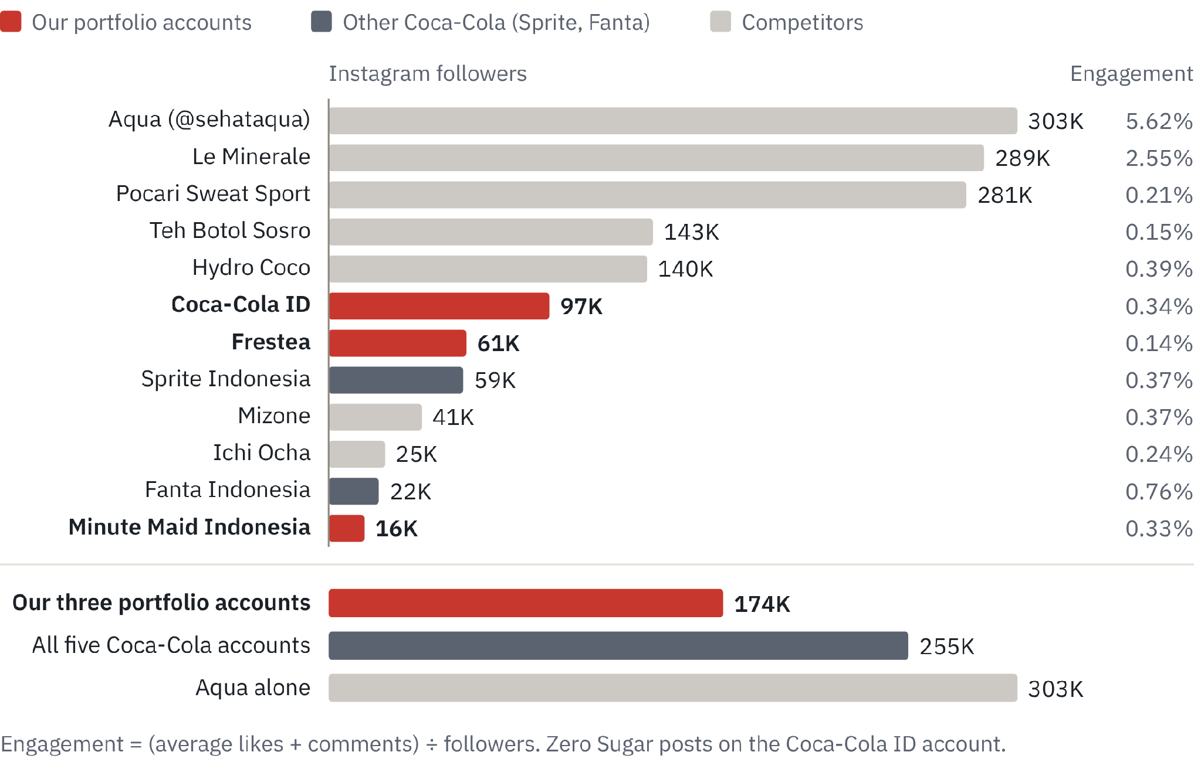
Figure 5. Instagram followers and engagement, 12 accounts, 18 Oct 2026. Source: Social Blade [10]; counts agree with HypeAuditor within about 5% [85]
The audit repeats the three gaps.
- No moments: Zero content chased novelty, and Ramadan 2026 hashtags covered Fanta, Sprite and Frestea, not Zero [56].
- No path to purchase: no shoppable link or delivery-app tie-in on these accounts.
- No credible voice: beyond the launch nutritionist [86], no expert speaks for Powerade, and “pemanis buatan” questions are answered in the website FAQ [87], not on social; Aqua puts “Sehat” in its handle.
Table 9. TikTok, YouTube and dedicated accounts: competitors vs Coca-Cola Indonesia
Platform | Competitors | Coca-Cola Indonesia
TikTok followers | Aqua 1.4M (10 videos in 14 days); Pocari Sweat 230K (16 videos); Teh Botol 70K | No official account found; Frestea 1.5K, no videos in 14 days
YouTube subscribers | Aqua 985K; Le Minerale 121K; Teh Botol 55K | No local channel; the website links to the global channel [11]
Dedicated accounts | Pocari runs a sports sub-account (@pocarisportid) | None found for Zero or Ades; Powerade not audited
Source: Social Blade and HypeAuditor, 5 to 18 Oct 2026 [10, 85]. Powerade’s own accounts and Pocari’s main Instagram (@pocariid, about 165K) were not audited.
What we can build on: a 97K master-brand Instagram, on-pack QR mechanics from Share a Coke [57], Frestea’s 2023 gamified Ramadan campaign [63] and forum interest in Coke Zero Vanilla [40].
The next post is “Makan pakai Zero” (eat with Zero), published on Mon 7 Dec 2026 as the first post on the new official TikTok, with 6–8 food creators posting that week. It is a 20-second video of a level-5 ayam geprek and an ice-cold Zero. Caption: “Ayam geprek level 5 + Coca-Cola Zero Sugar dingin. Pedasnya nampol, gulanya nol (mengandung pemanis buatan). Tambah Zero ke pesanan GrabFood-mu pakai kode MAKANPAKAIZERO. Kamu tim level berapa? #MakanPakaiZero #CocaColaZeroSugar”. It claims one product fact, “0 g gula”, with the sweetener disclosed. Targets: 10,000 code redemptions in four weeks in Jakarta (below 3,000 we re-cut the hook), 25%+ completion and 1%+ shares.
We considered two alternatives. #BukberPakaiZero waits for Ramadan (Feb 2027); a dietitian label explainer cannot carry product, so it runs as a standalone post. “Lari bareng”, “Rehat dulu” and “Jam tiga sore” follow under the same rules: label facts only, adults 18+, and experts who explain in general and never sit with the product.

10. Strategic implications
Three plays close the three gaps and a capped fourth tests tea and juice: US$10M over 2027–2031 behind three gates; CCEP data must confirm the shelf gap before Play 2 scales.
By brand, Zero gets US$5.8M (Plays 1 and 2, plus US$0.2M of Play 3’s label-reading content), Powerade US$1.6M (the rest of Play 3), Frestea and Minute Maid US$1.0M (Play 4) and the shared foundation US$1.6M. Play 4 is a capped test; Frestea Green Tea’s rise (22 to 31) shows a Frestea score can still grow [9].
Table 10. The four plays and the shared foundation: budget, scope and lead KPIs
Play | Gap | US$M | What it funds | Lead KPIs (2028, 2031)
1. Put Zero in soda moments | Moment | 3.4 | “Bukber pakai Zero” Ramadan bundles with GrabFood and GrabMart, and iftar sampling 1.3; “Makan pakai Zero” meal bundles 0.7; nongkrong and football-night sampling 0.3; moment creators 1.1 | Zero-sugar share of sparkling 7% → 10% (2028) → 15% (2031); Zero lift vs two holdout cities +2 pts (2028), +3 pts (2031)
2. Put Zero within reach (with CCEP) | Shelf | 2.2 | Chillers, shelf kits and retailer rewards in 20,000 outlets 1.2; quick-commerce listings, retail media and vouchers 1.0 | Zero cold in priority outlets 15K (2028), 20K (2031)
3. Credible voices for Zero and Powerade | Trust | 1.8 | Expert creators who explain in general and never sit with the product 0.8 (0.2 of it on general label-reading content, on Zero’s content line; 0.6 sports experts); “Lari bareng” with 30 run clubs 0.6; cool-down zones at 4 races a year 0.2; signage in 200 gyms and courts 0.2 | Powerade Top Brand Index score 5+ (2029), 15+ (2031)
4. Facts first for tea and juice | Outside the three gaps (capped test) | 1.0 | “Rehat dulu”: Frestea lunch bundles and desk-break sampling 0.4; “Jam tiga sore” for Pulpy’s vitamin C and real-tea content for Frestea 0.3; facings in 5,000 minimarkets 0.3 | Frestea Top Brand Index 12 (2028), 15 (2031); Minute Maid consideration +3 pts (2028), +5 (2031)
Shared foundation | All | 1.6 | Official TikTok and Instagram with listening 0.8; tracker, geo tests and interviews 0.6; reserve 0.2 | Cost per new Zero buyer, read at each gate; official TikTok followers 500K (2028), 1M (2031)
Source: team plan; US$1 = Rp18,000 [16]. Zero-sugar share covers Zero Sugar, Sprite Zero and Fanta Zero on CCEP’s basis; the two holdout cities stay dark through 2031. KPI targets are team proposals.
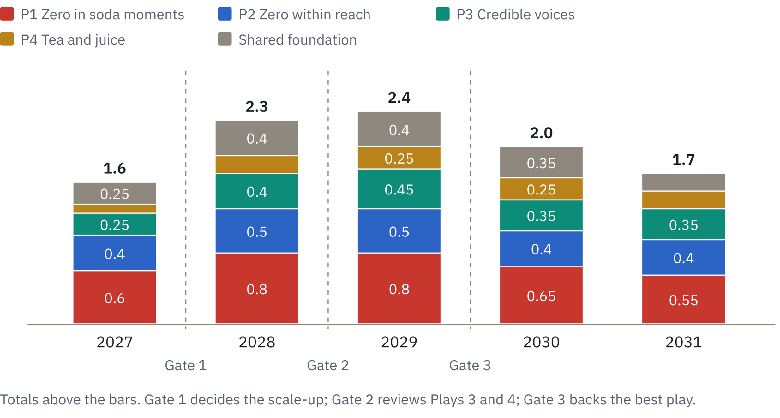
Figure 6. Budget by year and play, 2027 to 2031, US$M. Source: team allocation, as in the strategy deck; US$1 = Rp18,000 [16]
Table 11. Illustrative return scenario, per year at scale and over 2027–31 (all inputs are team assumptions)
Per year at scale | Low | Base | High
New Zero buyers | 0.55M | 0.95M | 1.3M
Zero servings per new buyer a year | 12 | 21 | 28
Share that is net-new, not switched from our drinks | 40% | 55% | 65%
Net-new Zero servings | 2.6M | 11.0M | 23.7M
Net-new Powerade servings | 1.5M | 3.5M | 6.0M
Net-new Frestea and Pulpy bottles | 0.8M | 2.0M | 3.5M
Net-new contribution | Rp10.7bn | Rp37.2bn | Rp76.2bn
At-scale multiple of the Rp36bn average yearly spend | 0.3× | 1.0× | 2.1×
Multiple over 2027–31 (2027 and 2028 at 25% and 60% of scale) | 0.2× | 0.8× | 1.6×
Source: team assumptions; shelf prices [52, 58, 64]. The 2027–31 multiple is at-scale contribution × 3.85 years ÷ Rp180bn.
At scale the base case repays its yearly spend (1.0×); over 2027–31 it returns about 0.8× because 2027 and 2028 are ramp years (assumed 25% and 60% of an at-scale year); the end-2027 gate limits the downside. Contribution is 30% of shelf price: Zero Rp8,400 [52], Powerade Rp6,000 [58], Frestea Rp4,460 and Pulpy Rp6,457 [64]. The base case also takes ~380 t of sugar a year out of drinks we sell, if each switched serving replaces a 390 ml Original.
Gates. End-2027: scale only if pilot cities beat holdout cities on zero-sugar share and cost per new buyer. End-2028: Play 4 kept if Frestea index 12 and Minute Maid consideration +3; Play 3 kept if Powerade consideration beats its 2027 baseline. End-2029: move 2030–31 money to the best play. KPI targets are team proposals.
Decisions needed now: approve the 2027 test budget of US$1.6M; agree CCEP co-funding for Zero visibility, coolers and affordable packs; approve an official TikTok and claims rules (never “healthy”); brief R&D on Frestea recipes below 6 g sugar per 100 ml, so Melati grades B with margin and more flavours join it.

11. Outlook and watch-list, 2027–2031
The next 18 months bring the plan’s test and a possible tax decision; labels become mandatory in mid-2028, after the first gate.
Two outside dates matter most: the excise (H2 2027) and mandatory labels (17 Jun 2028) [4, 5, 28, 29].
Table 12. Signals that would change the plan, and the response
Signal | Response
The excise is set on sugar content | Zero, Ades and Frestea Melati at B gain a price edge; bring Play 2’s packs forward
Excise (targeted H2 2027) or mandatory Nutri-Level (17 Jun 2028, Zero graded C) blurs Zero’s edge | Sell Zero on taste and “0 g gula” in its moments, not on the grade; read zero-sugar share against the holdout cities at Gate 2
A sweetener scare flares again | Answer with the label and the BPOM registration; hold stevia recipes in reserve
Grab declines the code or bundles | Fall back to GoFood and ShopeeFood; the creator content runs unchanged
Boycott sentiment returns | Local pride: Indonesian food culture and Indonesian creators; no political content
Pilots track the low case | Gate 1 stops the scale-up; the money moves to whichever play beats the holdout cities
Source: team plan; outside dates [4, 5, 28, 29].
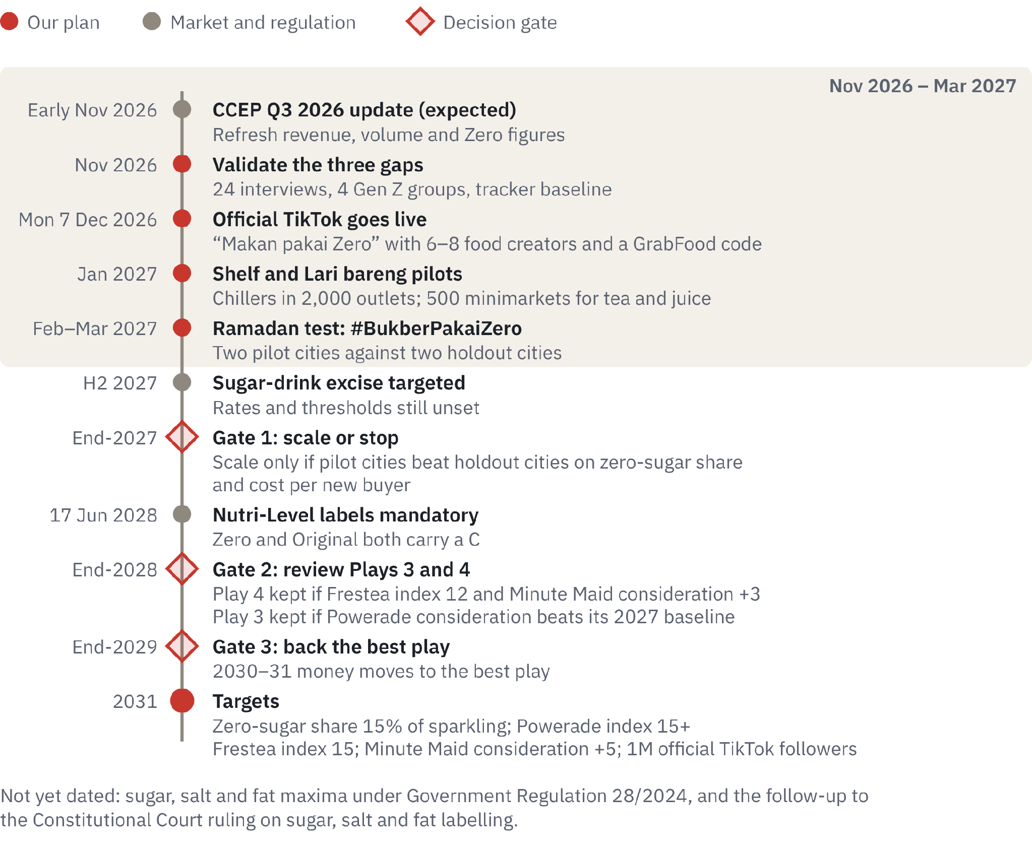
Figure 7. Milestones and decision gates, November 2026 to 2031. Source: regulatory dates [4, 5, 28, 29]; plan dates from the strategy deck; Q3 update date inferred from CCEP’s past timing

Appendix A. Methodology, limitations and data conflicts
Every figure comes from a public source read by 18 Oct 2026; estimates are labelled as team assumptions. The report uses no internal Coca-Cola data.
- Evidence base. Four research streams (market, regulation and health; Coca-Cola’s filings and calls; consumers, channels and media costs; a social audit of 19 accounts on three platforms), plus 477 forum comments and 13 analogue cases.
- Verification. Every figure was re-checked against its source on 18 Oct 2026 and corrections applied (Original grades C, not D). Added context figures rest on one source each.
- Known limits. Market-share data (Euromonitor, Nielsen) is paywalled, so the Top Brand Index stands in. CCEP does not disclose Indonesian volume, and the 3% to 7% Zeros mix has no stated period or base. Nutri-Level cut-offs come from BPOM’s release and Cekindo; the Health Minister’s grading rests on one secondary report. Social metrics move daily; the forum scan is qualitative; YouGov’s 47% dates from about 2019.
- Conflicts. CCEP’s pages disagree on outlets (400,000 vs 450,000) and plants (5 vs 8); we use 400,000 from its current website. Traditional trade is 67% of FMCG sales (Kantar) and about 70% of drinks volume (CCEP). The brief’s “biggest Southeast Asian market” holds for population, not revenue.
- Claims. Any wording beyond the label facts (“0 g gula” with “mengandung pemanis buatan”, “mengandung elektrolit”, “mengandung vitamin C”, real tea, sugar grams) needs BPOM claims and legal sign-off. Experts explain in general and never sit with the product.

Appendix B. References
All pages accessed on or before 18 Oct 2026 unless a date is given. References are numbered in order of first citation.
- CCEP, Capital Markets Event, Manila, deck, 14 May 2025 and transcript
- Cargill Ingredient Tracker 2025, via Investortrust, 17 Sep 2026
- CNA Indonesia, sugary-drink frequency from SKI 2023, 21 Oct 2024
- BPOM, Nutri-Level press release on BPOM Regulation 10/2026, 30 Jul 2026
- Cekindo, Nutri-Level cut-offs under BPOM Regulation 10/2026, Sep 2026
- CCEP, FY2024 results (6-K), 14 Feb 2025 and annual report (20-F), 21 Mar 2025
- CCEP, preliminary unaudited FY2025 results, 17 Feb 2026
- CCEP, results for the six months ended 3 July 2026, 4 Aug 2026
- Top Brand Award, Top Brand Index 2024–2026
- Social Blade, public Instagram, TikTok and YouTube pages, accessed 18 Oct 2026
- Coca-Cola Indonesia, brand pages (Zero Sugar, Powerade, Frestea, Minute Maid), accessed 18 Oct 2026
- Sharp, B., How Brands Grow, Oxford University Press, 2010
- Coca-Cola Indonesia, Powerade launch release, 19 May 2026
- BPOM product registration, Coca-Cola Zero (PT Coca-Cola Bottling Indonesia), approved 2 Feb 2025, via productlist.id
- CCEP Indonesia, company website, accessed 18 Oct 2026
- Bisnis.com, rupiah closing rate, 8 Oct 2026
- BPS, SUPAS 2025 population, via Bisnis.com, 5 May 2026
- BPS, Gen Z and Millennial share of population 2025, via Databoks, 5 Jun 2026
- ASRIM, via Bisnis.com, soft-drink industry outlook, 3 Dec 2025
- Euromonitor, Carbonates in Indonesia, public summary, Nov 2025
- YouGov, Pepsi fizzes out in Indonesia, c. 2019
- Jakpat via GoodStats, drinks Gen Z and Millennials consume often (fieldwork Apr 2026, n=1,238), 27 Jun 2026
- BPS, middle-class size 2019–2024, via Bisnis.com, 29 Aug 2024
- BPS, Q2 2026 GDP and household consumption, via Bisnis.com, 5 Aug 2026
- PwC Indonesia, Voice of the Consumer 2026 (n=503), 3 Sep 2026
- IDF Diabetes Atlas, Indonesia country report, 11th edition (2025)
- Ministry of Health, adult obesity (SKI 2023), 8 May 2026
- Republika, sugar-drink excise targeted from H2 2027, 9 Oct 2026
- DDTCNews, sugar-drink excise 2027 target, 9 Oct 2026
- Gebrak, Government Regulation 28/2024 on sugar, salt and fat, Aug 2024
- Katadata, YLKI urges sugar, salt and fat warning labels after the Constitutional Court ruling, 2 Oct 2026
- KlikDokter, myths and facts about soda, 19 Oct 2020
- KlikDokter, is low-calorie soda healthier?, 18 Jun 2021
- Antara, Health Ministry urges limits on artificial sweeteners, 16 Jul 2023
- BPOM, public explanation on the safety of aspartame, 25 Jul 2023
- Kontan, industry asks for time to adapt to Nutri-Level (Ministry of Industry), 22 Apr 2026
- iNews via RCTI+, Health Minister on stevia and artificial sweeteners, 22 Jun 2026
- Jakpat, Healthy living and coffee trends in 2025 (n=601), 4 Jul 2025
- Katadata Insight Center via Databoks, adding sugar to drinks (n=642), Apr 2023
- r/indonesia (Reddit), selected threads from the team’s scan of 477 comments, 2020–2026: g6m4ta, lk8otj, v59bqi, 1ilcwxk, 1laur7f, 1ovputz, 1ou2swh, 17u18l8, 17vhzbk
- Populix via GoodStats, health trends shaping purchases (n=1,100), 6 Dec 2025
- NielsenIQ, Indonesian consumers reassess health priorities, Jul 2025
- GoodStats, favourite drinks to break the fast, Ramadan 2026 (n=1,000), 6 Mar 2026
- CCEP, Meet the markets: Indonesia, 2023
- Worldpanel by Numerator, Indonesia Ramadan 2026, 26 Aug 2026
- Marketeers Youth Choice Award 2026 via GoodStats, Gen Z’s favourite packaged tea (n=2,233), 18 Sep 2026
- CCEP, H1 2025 results, 6 Aug 2025
- FoodNavigator, CCEP on its Philippines acquisition and Indonesia realignment, 6 Mar 2024
- CCEP, Q1 2026 trading update, 28 Apr 2026
- CCEP, FY2025 results call transcript, via roic.ai, 17 Feb 2026
- Coca-Cola Indonesia, Coke Zero Sugar relaunch release, 16 Mar 2023
- Tokopedia, Coca-Cola Zero 390 ml and Coca-Cola Original 390 ml listings, 18 Oct 2026
- IndoTelko, Coca-Cola × Riot Games Ultimate Zero Sugar, 5 Aug 2023
- MerahPutih, Y3000 Zero Sugar made with AI, 1 Nov 2023
- Coca-Cola Indonesia, Creations page (K-Wave Zero Sugar), May 2024
- Coca-Cola Indonesia, Ramadan 2026 release (69,000+ moments), 13 Mar 2026
- Coca-Cola Indonesia, Share a Coke 2025 release, 16 Apr 2025
- Hemat.id, Powerade 400 ml price at Indomaret, accessed Oct 2026
- GNFI, running events in Indonesia and their economic impact, 1 Nov 2025
- Investortrust, BTN Jakarta International Marathon 2025, 29 Jun 2025
- Euromonitor, Sports Drinks in Indonesia, public summary, Nov 2025
- Coca-Cola Indonesia, Frestea full-sleeve relaunch and “rehat” positioning, 18 Sep 2025
- MMA, case study: Frestea × Grivy Ramadan gamified campaign, 2023
- K24Klik, Frestea Teh Melati 350 ml and Minute Maid Pulpy Orange 350 ml listings, 18 Oct 2026
- detikHealth, less-sugar drinks as a lifestyle (Teh Pucuk Harum Less Sugar), 17 Jun 2026
- CNN, how Pocari Sweat built its brand abroad, c. 2020
- dentsu, Pocari Sweat Ramadan horror-comedy campaign, 2 May 2025
- YouGov, Indonesia advertisers of the month, March 2024
- UKM Indonesia, Le Minerale’s market strategy, 5 Apr 2024
- Modash, Le Minerale sponsored creator posts, 2025–26
- Warta Ekonomi, packaged-tea strategies for millennials, 3 Sep 2018
- Bangkok Post, Haadthip homing in on non-sugar drinks, c. 2025
- Agro & Food Processing, Coca-Cola and PepsiCo launch Rs 10 no-sugar drinks, 22 Mar 2025
- Adsumo, Meta Ads CPM benchmarks for Indonesia, Oct 2026
- Olakses, citing Snippet, Indonesia influencer rates 2026, 9 Sep 2026
- HypeAuditor via DailySocial, influencer marketing in Indonesia (2023 data)
- Kantar Worldpanel via Databoks, FMCG sales by channel, Q1 2025
- Katadata, Alfamart store count, H1 2026, Aug 2026
- Fortune IDN, Indomaret store network, 2026
- Google, Temasek and Bain, e-Conomy SEA 2025 (Indonesia), via Google Indonesia blog, Nov 2025
- Koran Jakarta, GrabAds moment campaigns including Sprite on GrabMart, 20 Jul 2026
- DataReportal, Digital 2026: Indonesia, Nov 2025
- Jakpat, where Indonesians first discover viral trends (n=1,635), 31 Aug 2026
- We Are Social and Meltwater, Digital 2026 Indonesia, Nov 2025
- HypeAuditor, public Instagram and TikTok account pages, Oct 2026
- Selular.id, Powerade launch with a clinical nutritionist, 21 May 2026
- Coca-Cola Indonesia, frequently asked questions (sweeteners, diabetes), accessed Oct 2026

